📝 Notes
Apr 23, 2026

Contained Animal Management System | SolutionLab Kickoff
Invited Christian Ruiz Tyler Morton Francisco Perez Raul Montenegro wyldsolconsulting@gmail.com Claudiu Constantin
Attachments Contained Animal Management System | SolutionLab Kickoff
Meeting records Transcript Recording

Summary
The kickoff established team roles and project goals for a centralized bull management system via collaborative workshops.
Team Roles and Framework
The team aligned on specialized roles for technology, design, and product architecture while establishing Basecamp and Figma as primary tools. Participants defined the project as a 2-week discovery phase for a comprehensive animal management platform.
Brand Identity and Business
Stakeholders defined the brand personality as traditional yet modern with a focus on bold, premium communication. The business purpose is to centralize disconnected tools into a single platform for improved operational transparency and financial tracking.
MVP Scope and Functionality
The group decided the minimum viable product will focus on animal inventory management, media storage, and partnership record keeping. Defining ownership documentation as a foundation for future financial features remains the primary technical goal.

Rate this Summary: Helpful or Not Helpful

Decisions
We've updated the Decisions section using your feedback.
Let us know what you think: Helpful or Not Helpful

ALIGNED
- Cattle management system project scope The project scope is established as an end-to-end cattle management system designed to streamline operational processes from initial purchase through final sales.
- Project communication and design tools Basecamp is established as the central communication platform, and Figma is confirmed for all design and workshop collaborations.
- Application design and branding strategy The application design is set to be friendly, masculine, and premium, utilizing a grounded color palette including range green, rust, dirt, and soft white.
- Subscription-based business model The application will operate using a subscription-based business model.
- MVP success definition The MVP is considered successful if it securely stores inventory, manages media files directly within the application, and visually displays partnership data.
- MVP scope defined The MVP scope is set to include loading animal inventory, recording media, and collecting partnerships, explicitly excluding feed rates and invoicing features.
- Global animal persistence strategy established The system architecture is established as a persistent, global database where animal records remain accessible for all users regardless of ownership changes.

Next steps
- [Simonet Shazim] Collect Feedback: Contact customer after engagement completion. Obtain feedback via short email or quick 15 minute call.
- [WyldSol] Submit Branding: Send over branding kit including natural color range, logo, name, and SVG/PDF files.
- [WyldSol] Detail Competitors: Provide examples of competitor websites and detail likes or dislikes for each.
- [WyldSol] Supply Insights: Offer insights regarding communication language that clicks with users.
- [WyldSol] Send Metrics: Share documented success metrics for amounts of customers and program goals.
- [WyldSol] Send Inventory: Send Francisco Perez example of inventory sheet.
- [Francisco Perez] Decide Platform: Lay out platform advantages for App Store versus responsive design decision.
- [Francisco Perez] Review Terms: Read industry terms mentioned to become more informed.
- [Christian Ruiz] Check API: Look up if the American Booking Bull Institution provides an API.
- [WyldSol] Document Workflows: Think through and send over feature workflows documentation.

Details
Did the screenshots in this section make your notes better or worse?
- Solution Lab Kickoff Agenda: Francisco Perez welcomed participants to the solution lab kickoff and outlined the agenda, which included team introductions, a project overview, an explanation of the design and product creation frameworks used, establishing communication channels, and reviewing the meeting structure and next steps (00:00:02).
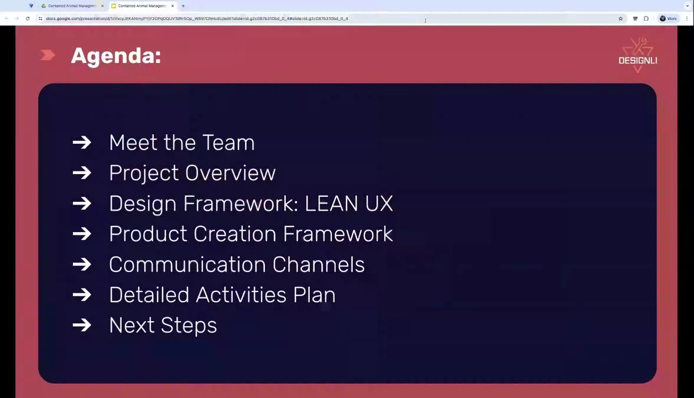
- Team Introductions: Core Team Roles: The core team members were introduced: Christian Ruiz as the tech lead, responsible for validating feature viability, sizing, and creating the roadmap. Claudiu Constantine is the UX and UI designer, who will be working on creating the prototype and screens, receiving feedback on designs and flows (00:00:54). Francisco Perez, the solutions architect, is leading the team, facilitating workshops, and handling the product creation side of discovery (00:01:52).
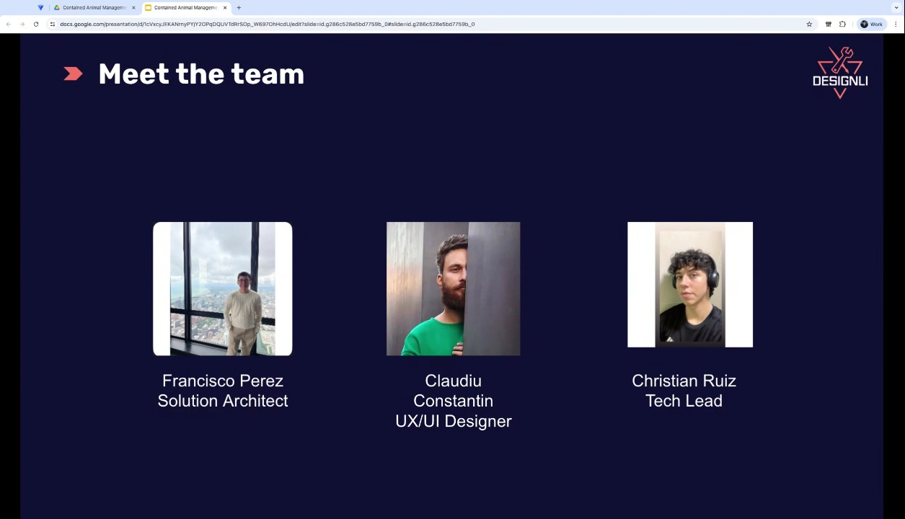
- Team Introductions: Customer Success Representative: Francisco Perez mentioned a key team member not present, Simonet Shazim, the customer success representative. They will contact the clients after the solution process concludes to gather feedback, which may involve a short email or a 15-minute call (00:01:52).
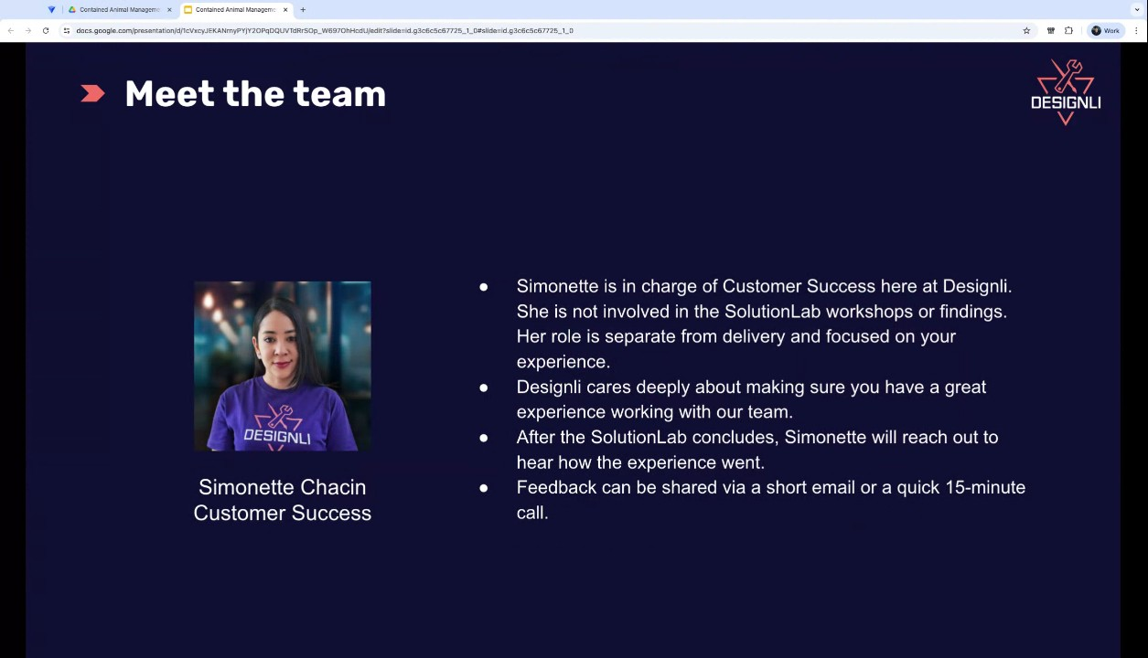
- Solution Lab Overview: Project Goal: The project is a product discovery and UX/UI design phase focused on creating a comprehensive animal management system. The system aims to streamline the end-to-end process for bulls, eventually extending to horses and other animals, covering everything from purchase through ranch care to final sales. The general idea is to deliver holistic animal care by integrating current disconnected management processes into a single centralized platform (00:02:49).
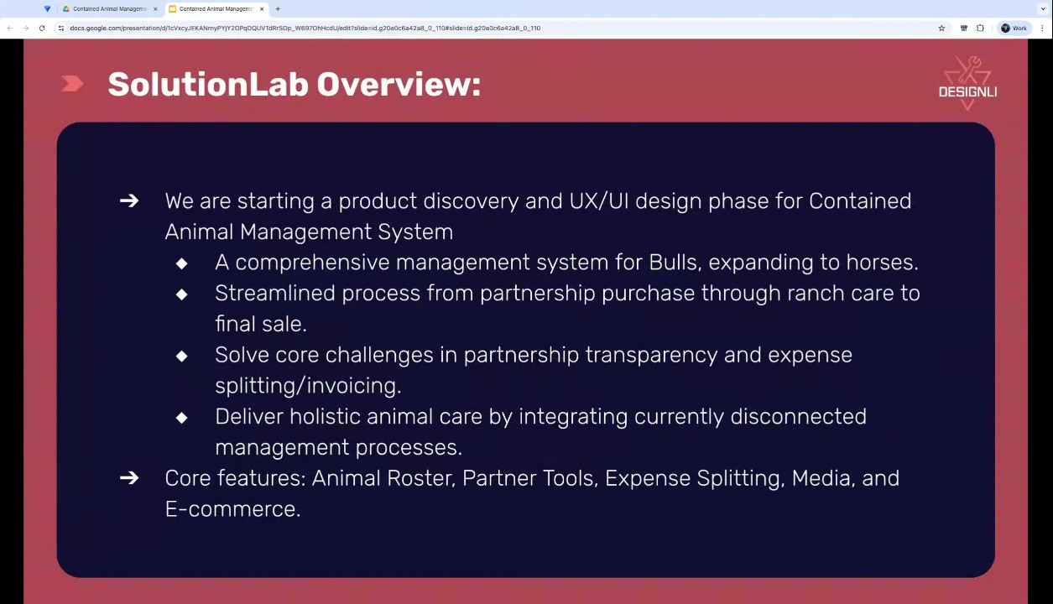
- Solution Lab Overview: Core Challenges and Features: Key background information includes addressing core challenges related to transparency and expense splitting/invoicing for customers. The solution should also incorporate core features like the animal roster, partner tools, and expense splitting, which will be explored further in upcoming workshops (00:02:49).
- Engagement Structure and Framework: The engagement will last two work weeks, though it spans into the third week due to the Thursday start date (00:04:14). The design framework used is called Lingux, an iterative process focusing on sketching, presenting, and critiquing the prototype, with the client providing real-time and asynchronous feedback (00:05:09).
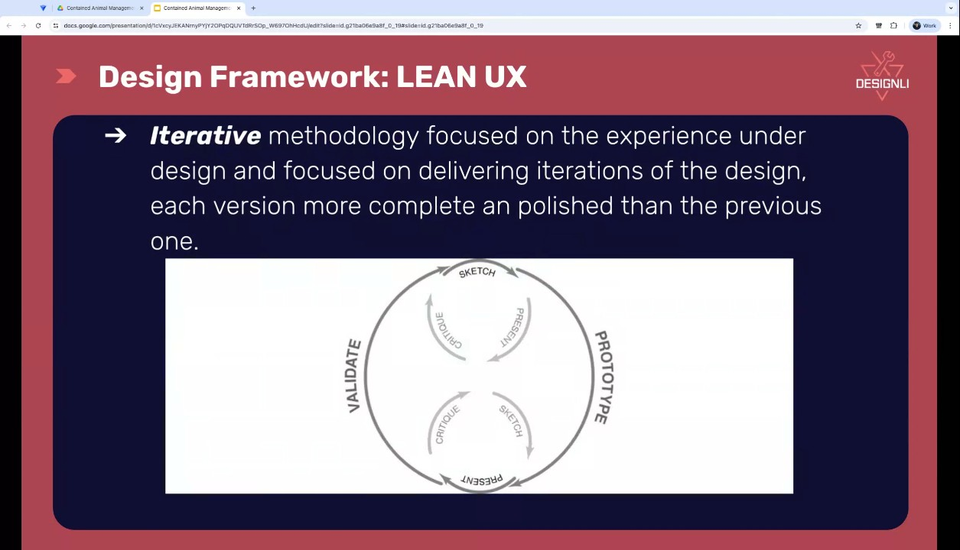
- Meeting Schedule and Structure: The process involves a series of workshops and design review meetings. The first solution session, focused on understanding the business, was scheduled for the same day as the kickoff, and the second session, "understanding the actors," was scheduled for the following day (00:06:16). The following week will include two design reviews and a workshop focusing on platform features, with a final workshop planned for prioritizing and determining the minimum viable product (MVP) scope (00:07:14).
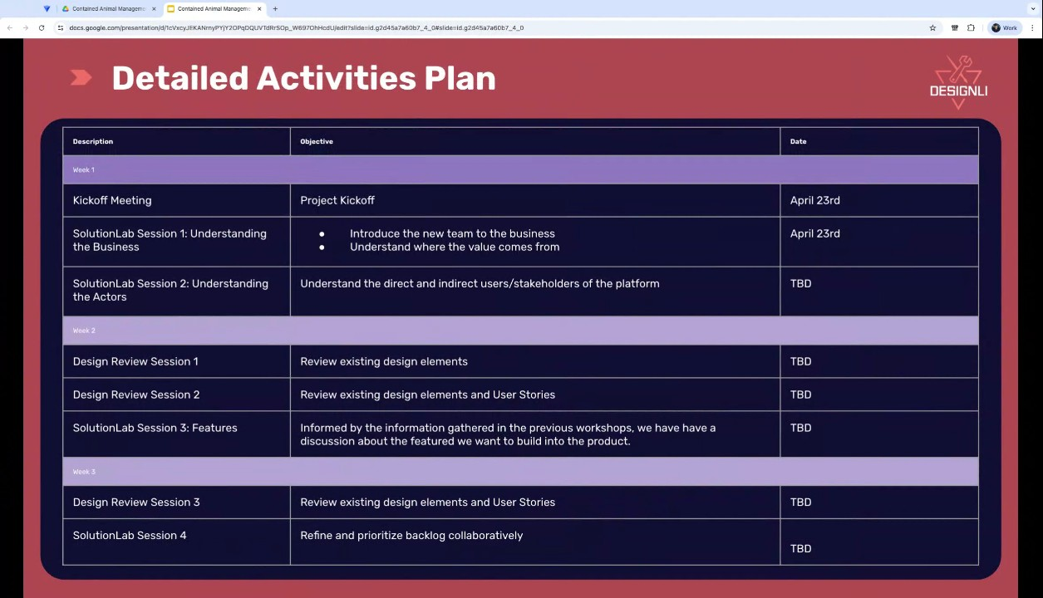
- Communication Channels: Two main platforms will be used for communication: Basecamp and Figma. Basecamp will centralize communication, serving as an email replacement, and will be used to post meeting links, recordings, and notes (00:09:13). Figma will be used for workshops and design work, allowing users to leave direct comments and feedback on design elements (00:10:12).
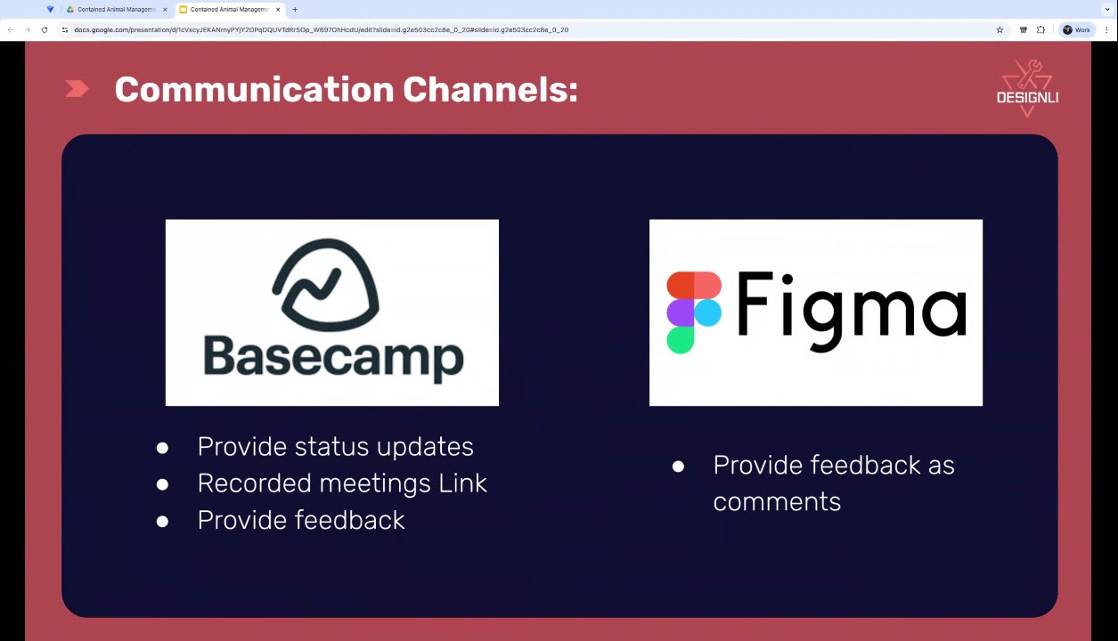
- Initial Workshop: Look and Feel/Brand Identity: The team began the first workshop by discussing the desired look and feel of the application (00:12:59) (00:24:00). WyldSol requested a design that is very easy to use, visual, and has straightforward workflows, avoiding technical jargon and excessive use of icons (00:25:02). They prefer a look that is "traditional" yet "modern," not flashy or overly slick, with colors that are grounded (00:26:35).
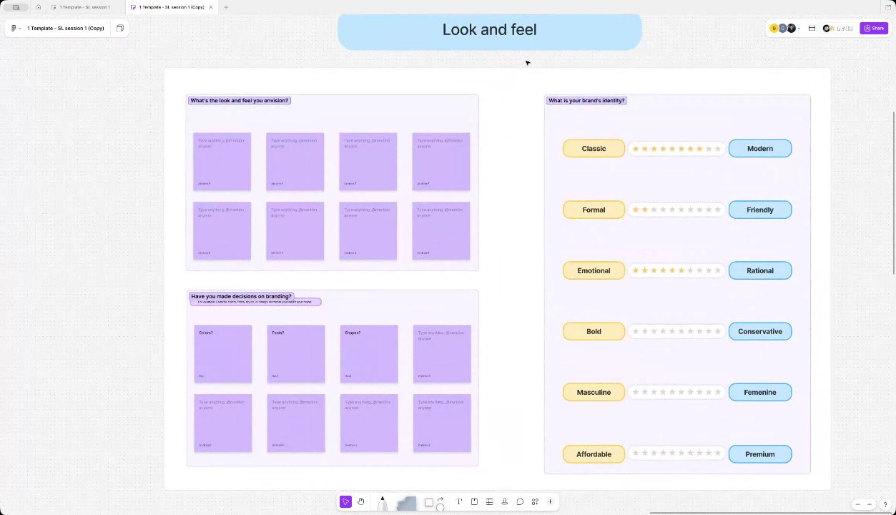
- Branding and Identity Decisions: WyldSol confirmed they have a branding kit, which includes natural colors like a range green, black, a soft white, a rust color, and a dirt-like color (00:27:39). The application should feel very friendly and fall in the middle of emotional and rational displays of information (00:28:31). The brand personality should lean towards bold for simple, short, and to-the-point messaging, and the language should feel mostly masculine and premium (00:29:29).
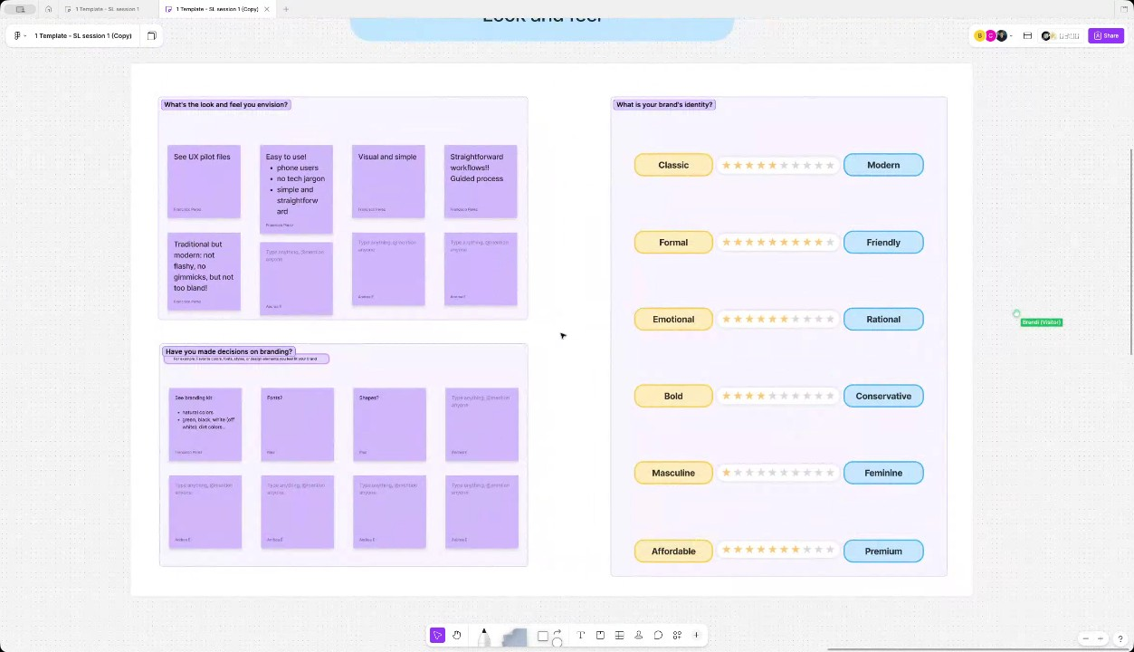
- Business Overview: Industry and Purpose: WyldSol explained that the application's main purpose is to bring together the disconnected tools currently used, such as spreadsheets, phone texts, media, and basic invoicing via QuickBooks (00:34:16). The goal is to improve operational control, financial control through expense splits, traceability, and stakeholder visibility in the niche industry of bull and lineage management (00:35:30).
- Business Overview: Value Proposition and Pain Points: The industry makes money by breeding, training, and selling animals based on their bloodline and performance in competitions (00:37:03). The application was conceived due to a lack of transparency and difficulty tracking finances, especially during tax time (00:38:35). Major pain points include managing media (videos of bucking/training) across different animals on a phone, disseminating information to multiple partners, and accurately splitting invoices, as costs vary based on the animal's age and a rancher's commission may make them a "backdoor partner" (00:40:55).
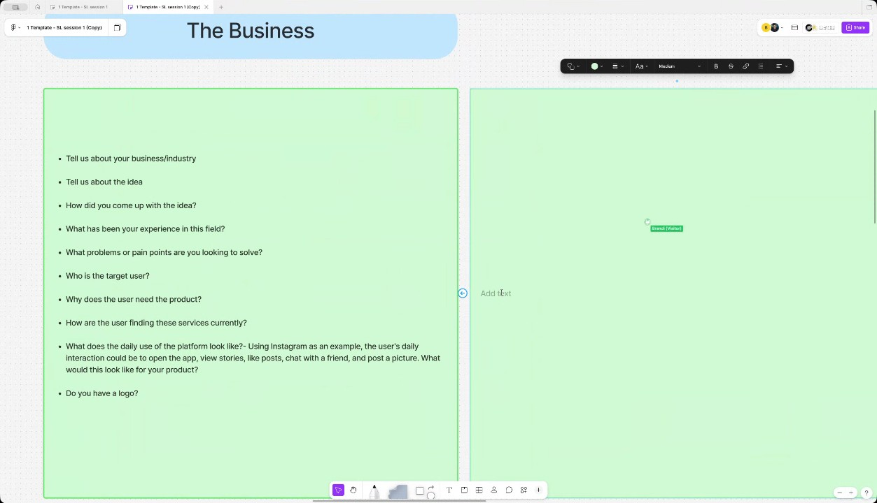
- Target Users and Roles: WyldSol identified three levels of users, starting with the **Rancher**, who is the main user responsible for day-to-day operations, including feeding, hauling, and vet visits (00:43:28). The second level is the **Owner**, who buys herds, manages their own sales, but lets the Rancher provide care. The third level is the **Partner**, a read-only user who invests money into a bull and wants to track their investment and profits, often without traveling to see the animals (00:44:39).
- Application Daily Use and Workflow: The application's daily use will revolve around the Rancher's operations, starting with accessing the inventory to choose one or many animals (00:45:52) (00:56:18). From there, they perform actions such as charging for feed, loading animals for competition, or invoicing. Other actions include recording media (e.g., video of bucking) on a single animal, which is then made available to stakeholders and partners (00:57:31). The Rancher will continuously use the app throughout the day for these activities (00:46:44).
- Monetization and Success Metrics: The application will use a three-tiered subscription model, and while it will mostly be used on mobile, it will also have a web/laptop interface to manage large data input, such as buying 300 cows (00:49:47). Future cost savings will come from the creation of brochures for sales using existing media and data. The measure of MVP success is achieved when users trust the product to hold their entire inventory, use the app for media storage/execution instead of their phone's camera, and effectively collect and visualize partnership data on the bull itself (00:50:59).
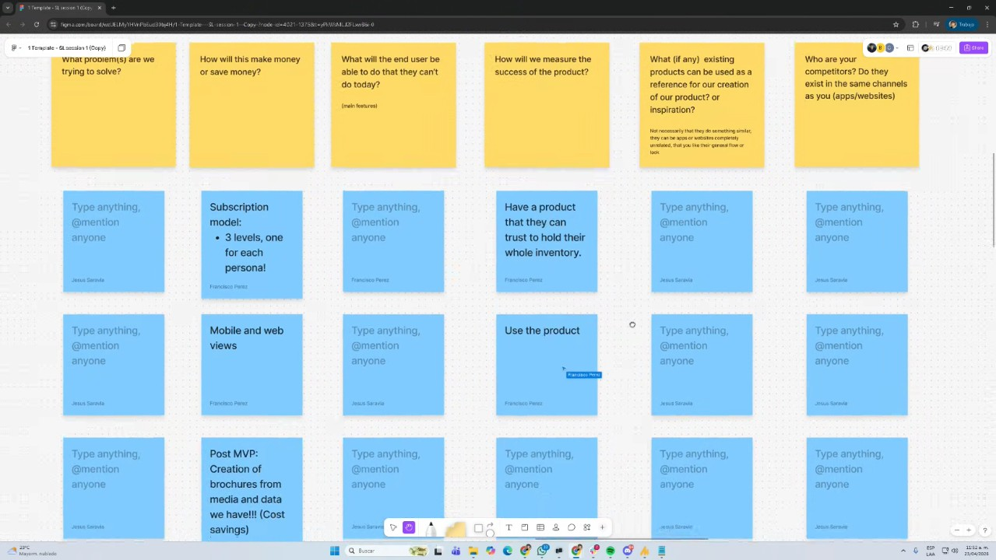
- Future Success Criteria and Competitors: Beyond the MVP, success will be measured by achieving the end-to-end flow: buying, inputting partnership invoice data, and selling. A future success criterion involves integrating with the American Bucking Bulls Incorporated (ABBI) via an API to pull lineage data required for DNA testing and competition records (00:53:25). Currently, WyldSol has found no direct competitor offering a holistic experience connecting inventory, media, and partnership invoicing (00:55:00).
- Minimum Viable Product (MVP) Definition: WyldSol defined the MVP scope as loading the animal inventory, being able to record or add media to the animals, and collecting the partnerships. The MVP would exclude features like rates for the feeds and invoicing. Francisco Perez noted that other actions besides choosing an animal to record media would be post-MVP (00:59:06).
- Partnership Functionality at MVP: The initial functionality for partnerships centers on ownership documentation, where an animal is entered as 100% owned by the user until they document a partner's percentage, such as 40% for another user. This foundational ownership record is critical for future features, like calculating charges for feed and mileage based on percentage ownership (01:00:31).
- Stakeholder Notifications: The system's partnership functionality should innately identify partners as stakeholders, who would then receive system notifications. WyldSol confirmed that partners are the stakeholders to be notified by the system (01:01:45).
- Animal Onboarding Process: The process for onboarding an animal into the inventory is considered generally simple (01:01:45). The two required fields for entry are the animal's brand ID (the number on their ear tag) and their birth date, as these details are important for future use (01:02:42).
- Optional Animal Onboarding Information: While brand ID and birth date are required, other information, such as the animal's name, who they were purchased from, and their ranch or location, can be added during onboarding or later (01:02:42). Additionally, the ABBI (American Booking Bull Institution) number, which is a unique identifier, is considered optional, and they also need to know if the animal is a cow or a bull (01:04:15).
- Multi-Tenant and Data Preservation Structure: Francisco Perez suggested the system should operate like a multi-tenant application, allowing management of information and user onboarding (01:05:33). WyldSol emphasized that once an animal is entered into the inventory, like a bull, the historical data must be preserved and remain available in the database, even if the animal is sold and leaves the current owner's inventory (01:06:48).
- Platform Access Expectations: The expectation is that all actions can be performed on both an application and a web platform. WyldSol is currently undecided on whether the application should be distributed through an app store and is seeking guidance on that decision (01:08:03).
- Integration with American Booking Bull Institution (ABBI) Data: Christian Ruiz confirmed that the information on the bulls from the ABBI is public, though they have other data behind a subscription (01:09:04). WyldSol noted that ABBI currently does not have an API as their architecture is older, but they are willing to work with them to potentially obtain the data directly from their database (01:10:03).

You should review Gemini's notes to make sure they're accurate. Get tips and learn how Gemini takes notes
How is the quality of these specific notes? Take a short survey to let us know your feedback, including how helpful the notes were for your needs.

📖 Transcript
Apr 23, 2026

Contained Animal Management System | SolutionLab Kickoff - Transcript

00:00:02

Francisco Perez: All right. So, thank you very much. Nice to meet you. Uh, welcome to this solution lab kickoff. Today, we want to cover uh,
WyldSol: useful.
Francisco Perez: a couple of items in the agenda before we jump right into the the workshop that we have planned for today. So, first we're going to be meeting the team. Uh, that's kind of like happens in two parts. I'm going to be explaining in this in this session uh, what the role of each team member is and then we will get to know each other better. Um after that we're going to get a project overview just of you know to to set in in in place what we know about the project and everything that we are working with uh from the start. After that I want to take some time to explain to you the design framework we use uh as well as a per creation framework uh establish some communication channels and also uh let you know how that framework translates into the meetings we're going to have in this twoe process and move into next steps.

00:00:54

Francisco Perez: So let's begin by uh introductions. So here in the meeting we have uh the three main team members that's going to be working with you. Uh the first one is Kissian. Is our tech lead. So he's going to be uh validating and making sure that everything that we propose in terms of features with the design and everything that also needs to happen in the application it's viable and we have a way or a plan of action to do it when moving to development. So he's going to be uh making sure of that and and also helping us with uh sizing and creating the road map later. Uh so that's Christian Ruiz. Then we have Cladio Constantine. He's our UX and UI designer and he's going to be the one that is going to be working mostly on the creation of the prototype and the screens for the project. So you're going to be having uh a lot of time with him working on the designs and getting giving some feedback to him also on the screens he creates and the flows and his recommendations.

00:01:52

Francisco Perez: And last but not least, Francisco Perez. I'm the solutions architect for this project and I'm going to be leading the team towards the effort uh towards the goal that we want to achieve. Uh and I'm going to be taking care of the perk uh side of the discovery. Right? So basically I'm going to be facilitating workshops so that the team has everything they need to uh work on both the development side of things and also the design side of things. Uh now there is a really important team member that is not present in the meeting. Her name is Simonet Shazim. She's our customer success uh representative and being in charge in of customer success here at design. is going to be uh contacting you after after the solution finishes, the process finishes so that you can give her some feedback. Basically, let her know what went well, maybe if there's any point of improvement. Uh that could be either a short email that she's going to write to you or a quick 15 minute call.

00:02:49

Francisco Perez: So, expect some news from her after we finish the engagement. Um now, let's move on to the solution lab overview. So we are starting this product discovery and UX UI design phase for uh creating a contain animal management system. So what we know as background information well that we want to build a comprehensive management system for bulls but also extend to horses and other animals uh in the future right and the idea is to streamline the process uh from the partnership purchase through ranch care to final sales. So basically the whole end to end process as I understand uh that's something that you're going to be helping us understand a little bit better because we're not that um knowledgeable on on on the area but that's why you you are also here in the in the the engagement right um uh you already provided some information about some core challenges uh in terms of the transparency and the expense splitting or invoicing for customers. So we want to understand that also a little bit better and the general idea is that we can deliver a holistic animal care by integrating uh current disconnected management processes right so I get that this whole uh end to end process is not really centralized into a single platform but the idea is to do that and in that sense deliver that holistic care uh that encompasses all of the steps and areas right and you also I think you also share with uh Tyler a couple of core features so the animal roster the partner tools,

00:04:14

Francisco Perez: the expense splitting, all of those things. We're going to be deep diving into them in the in the different workshops we have to understand them a little bit better uh so that we can build uh an idea a concept and the prototype for it that makes sense uh for for both moving next text next steps with development and also sharing the idea with the prototype. I don't know if there's any comment any correction amendment to what I mentioned here as an overview.
WyldSol: No,
Francisco Perez: Okay, nice. Um, excellent.
WyldSol: no.
Francisco Perez: So, let's move on now to the engagement itself, right? So, the engagement is going to last two weeks uh with the following team allocations. So we have a UX and UI designer assigned 40 hours per week that that is Cladio. Uh the product owner which in this case is going to be me as as a solutions architect. I'm going to be assigned 20 hours per week to this project. Uh my work is mostly well Cloud's work is mostly going to be on the design file.

00:05:09

Francisco Perez: Uh mine is mostly going to be preparing the workshops and also doing some homework in terms of investigation or coordination of the work we do. And uh Christian is going to be uh working also 20 hours per week. his job is going to be more of uh validating and investigating and consolidating all of that into a document that we also deliver with the rest of the of the deliverables. Um so that we have that information for either knowledge transfer or um also as uh a simp simple uh record of things that we worked on throughout the engagement. uh now these last two weeks but you will see that because we are starting on a Thursday it's going to span uh into the third week a little bit but the idea is two two work weeks um and let's take some time to take a look at the design framework we use here at designly we work in iterations iterations so that methodology we use which is called lingux focuses on building the experience under uh an iterative process right so as you can see here is a circle where we work on sketching presenting and getting your critique on what we build.

00:06:16

Francisco Perez: Uh and that basically consists you know the the iterations of that process consists on build building a prototype and validating that prototype with you. So the idea is that we're going to meet uh in in some design focused meetings that uh we're going to show you updates on and and also you're going to give us live feedback but you will also give us feedback as synchronously because you will get access to that file uh so that you we can get all of that information in real time. The idea is that we have no surprises when showing you something, right? That we are building this together and and by the end of the of the engagement. We're going to give you some deliverables that you already know uh what they consist of, right? Um so that is Linux. I'm going to explain in a second how that translates into meeting which is this specific table we're looking at here. So we are in these first two slots, right? So we have the kickoff meeting right now and after that we're going to jump right into the first solution of session which uh is for understanding the business better.

00:07:14

Francisco Perez: Uh that happens today. Uh then what we also want to would like to cover on this first week is the second solution of session which is titled understanding the actors. Uh we would need around an hour for this meeting. So preferably we would like to have it tomorrow but I don't know if that's fine with you in terms of scheduling. If not we can do it on Monday too. Um,
WyldSol: tomorrow be fine.
Francisco Perez: okay. Awesome. Does tomorrow the same time works for you? Okay, nice.
WyldSol: Yeah.
Francisco Perez: I'm going to let me just add that here. 4th um just for us to to well, I'm going to be sending the invite later today. So, for me to not forget. And the rest of the meetings we have, as I mentioned, workshops and design reviews. So design reviews are uh the meeting I just just explained where you we show you the the new designs and you give us feedback. We have two of them uh for next week and uh depending on how we do on these two workshops.

00:08:12

Francisco Perez: I'm going to let you know if that's going to be uh either Tuesday, Thursday or maybe Wednesday, Friday and uh we have planned another workshop here the solution of three where we are going to be looking a little bit more into the features of the platform itself. uh kind of like getting more information. You will see that the the building of the product is really collaboratively in terms of you know the design review really gets a lot of information that we need. The workshop mostly adapts to what we know at the moment and what we need to know for the next steps. So that's why this workshop is is is really important to fill in some gaps over there. Uh then we'll have another on the on the the next week we're going to have another uh design review session and one last workshop which is for prioritizing and uh basically deciding what to build first and what to build second and last uh in terms of building an MVP. Right? So we're going to be setting priorities and we're going to come with a plan so that we can present you a proposal for a road map that we can later discuss when we present the final deliverables.

00:09:13

Francisco Perez: So uh I don't know if you have any questions so far.
WyldSol: Nope.
Francisco Perez: Awesome.
WyldSol: Oh,
Francisco Perez: All right.
WyldSol: good.
Francisco Perez: So um I guess the only thing left for me to do before moving to the workshop is uh explaining to you what are the communication channels we're going to be using. So we have two main platforms that you're going to be seeing and getting emails from. The first one is Base Camp. Basec camp is where we're going to be centralizing the communication. Think of it as an email replacement platform. We like to use Basec Camp because everyone is uh posted on all of the information we are sharing. The idea is that we reduce any silos of information uh and that we don't rely on maybe me being you know the the main point of contact. I'm the main point of contact but uh the team should be on the know of everything we we we talk about. Right. So basecam is a place for centralizing that. Expect to have some meeting links and meeting recording links and um meeting notes also posted via basecam after each call.

00:10:12

Francisco Perez: And anything that you want to provide us in terms of files, feedback or any any concern or question, feel free to also use Bcam. If you would prefer to use email, that's fine for me. You can interact with Basecam via email or you will can send me an email, but I'm going to be also replicating that in Basecam. And the next one you see is Figma.
WyldSol: Okay.
Francisco Perez: So Figma is the tool we're going to be using for both workshops and the design, right? And for design, it's pretty important because uh you know it's it's a really uh useful tool for us because you can leave comments directly on top of design elements. So if you want some copyrighting to change for example or you or you want an icon to be a different color or a different style, then you can directly leave a comment on top of that element. Uh we're going to show uh once we get to a a design review how that works. But the idea is that once again you provide feedback in live format uh in the meetings but also as synchronously if there is any update to the file and and you have the time to check it and you can also leave that feedback and not wait for the meeting.

00:11:11

Francisco Perez: Um so yeah you're going to be getting an invite to base camp and we're going to share the signal once we meet for the design review. Um I think that's all from the presentation side of things. So the next thing we will have uh uh in the agenda is jumping right into the first workshop. But before we do that, I don't know if you have anything to add, Tyler, or if you have any any questions,
WyldSol: Uh,
Francisco Perez: Randy.
WyldSol: no questions. Um, just let you know I'm I'm really familiar with Figma,
Francisco Perez: Oh,
WyldSol: so
Francisco Perez: okay. Awesome. Great. Sounds
Tyler Morton: Nothing to add for me, Brandy. I'm going to go ahead and dismiss myself.
Francisco Perez: good.
Tyler Morton: Obviously, you're in good hands with the team here. I'll be checking back in with you towards the end of the two weeks uh to basically schedule the final proposal, final deliverables meeting with you to go over what we've accomplished over these past over these coming two weeks. Um if you have any questions at any point um or you need any assistance from me, please feel free to reach out to me to me directly.

00:12:05

Tyler Morton: Otherwise, Francis will be your main point of contact over the next two weeks.
Francisco Perez: Awesome.
Tyler Morton: Um but yeah, looking forward to seeing the results and um yeah, we'll I'll be in touch in the coming weeks.
WyldSol: Great. Thank
Tyler Morton: Thanks guys.
Francisco Perez: Thank you.
Tyler Morton: Have a great day.
Francisco Perez: Right.
Tyler Morton: Bye.
Francisco Perez: Thank you.
WyldSol: you.
Francisco Perez: Okay, let me stop the recording, the recording, sorry, the the screen sharing and let me change to Figma. Uh we're going to be doing this uh first workshop today. So the idea of this workshop is that we focus on three main aspects. Um so the first aspect we want to cover is some team introductions because you are already used to to Figma. I guess you know this part of this the idea of this introduc introductory exercise is for you to use the platform but it's going to be just an icebreaker activity then and uh after that we just want to have some some uh time to get to know the business a little bit better.

00:12:59

Francisco Perez: We want to know the background story the industry and everything that you can share with us. that will be useful for us to to to know uh regarding the building the platform. But before we do that, I think because I Claudia has to jump in in a second. Um we want to start also with uh establishing the look and feel and brand identity. So this is important for us to define elements of design uh that we will use in the in the reviews. Uh so we're going to maybe prioritize this. And last but not least, oh I think I stopped sharing. Right. And last but not least, we're going to be also looking at the uh workflow of the features that we want to build. Right. So maybe uh just really high level what are the different steps that we're going to be mapping in the in the designs and that's the agenda for this workshop. So let me begin by creating an open session here and sharing the link with you in the chat.

00:13:57

WyldSol: Are we just going over with all this stuff?
Francisco Perez: So please join me.
WyldSol: Are we going over just what we think the MVP is or are we going over holistically the entire
Francisco Perez: Oh yeah.
WyldSol: thing?
Francisco Perez: So for this for this workshop I I would like to start general. So if you have any any long-term plans uh that is not necessarily MVP, I think that would be useful for us to know.
WyldSol: Okay.
Francisco Perez: Uh and we're going to be focusing on the MVP as we move forward with the workshops.
WyldSol: Okay.
Francisco Perez: But in this case, we want to understand it in a more in a general sense. Yeah. Thank you. Okay.
WyldSol: Okay.
Francisco Perez: All righty. So, while you join us here in the file, let me explain the first exercise. So, it's really simple. Just pick some cards. Pick the color cards you prefer and fill in the questions. So the questions are your name, contact details, uh I know we have your email, but also if you would prefer us to use another address for something specific or uh a phone number maybe for contacting you um um in a in a more timely manner.

00:15:10

Francisco Perez: Uh then where are you located? What is the time zone of the location? Uh what is the role that we have in the project? That's what we already mentioned in the presentation. And the icebreaker which is just telling us something you like and something you dislike. That could be whatever, right? Could be related to work or personal. Um, so yeah, I'm gonna give uh everybody just a couple of minutes for this and let's start Okay, I think we are done. Um, so let me stop the timer and the music and let's um yeah, let's take a look at the cards. So, I'm going to start with mine. My name is Francisco Perez. You can call me Frank. Uh, I'm located in El Salvador. So, that is Central Standard Time. Oh, but but actually it's it's a little bit quirky because it's like central standard time without daylight savings, but essentially central time. Uh I I'm going to also share this via basecam.

00:18:37

Francisco Perez: You have my contact details here, the email we're using for for the meetings and everything, but I also will leave my uh mobile number here. If you want to reach out uh for anything that is more more urgent, feel free to give me a call or or a text. Uh my role in the project, as I mentioned, I'm going to be the solutions architect. So once again facilitating the information for the team with the workshops, coordinating the the efforts we do and working on um you know enabling basically the different team members to work on their expertise uh about things I like and what I'm disliking right now is that I don't know why I'm the screen sharing is just suddenly stopping but hopefully that's not recording but well anyways what I dislike in general I dislike bannon expensive food. So if you know I can stand bad food if it's cheap or I know what I'm getting or expensive but if it's worth it, right? But when you have expectations and it's bad and it's also expensive, that's where I really dislike that.

00:19:36

Francisco Perez: And things I do like on a positive note, I like music. I play the keyboard and piano. That's my hobby. So when I'm working, that's what I mostly tend to do. Uh and yeah, that's me. So nice to meet you and looking forward to working in the project. Okay, let's go ahead and see Cloudy's
Claudiu Constantin: Hey, so my name is Clauddio. Uh, that's how you spell it as well. You just say cloud and add the U at the end. Uh, I'm based in Bucharest. Uh, you have my contact details right there. I'm going to be your senior product designer for the solution lab. So, we're going to make something really awesome and cool. Um, something I dislike. So, rocket salad, coriander, and mostly people that say there's 30 minutes left on the hike, but it's really in reality it's like 2 hours or three. That's when I actually give up. I don't. Um, other than that, something I like is photography, music, um, animals in general, and, uh, a double link to cooking as well.

00:20:46

Francisco Perez: Nice. Thank you. What is rocket salad, by the way? It's part of my ignorance.
Claudiu Constantin: Uh, I think it's like orula if if
Francisco Perez: Oh, okay. Yeah. Yeah.
Claudiu Constantin: you
Francisco Perez: Okay. Yeah. And I relate to the hiking thing.
WyldSol: Yeah.
Francisco Perez: I prefer even if it's uh discouraging for
Claudiu Constantin: Oh, you won't believe it. That's how they trick me because they know I don't like to hike and they're like,
Francisco Perez: the
Claudiu Constantin: "Oh, don't you worry. Come on. It's only a half an hour fight." Like, okay, I trust you.
WyldSol: Thank you.
Claudiu Constantin: But then Friends,
Francisco Perez: Yeah.
WyldSol: Sure.
Francisco Perez: Okay. Thank you, Claudia. Uh yeah, let's check Bry's cards.
WyldSol: So, my name is Randy. Um, I'm the founder in this project. I'm located in Colorado um in the United States and I'm on Mountain Time Zone. So, yes, I do have the daylight and all that kind of fun stuff. I don't even know which one we're in right now.

00:21:39

WyldSol: But, um, my emails there. I have my personal email, my consulting email, and then my phone if you need to get a hold of me. Um, I don't like snakes, um, cold weather and rude people. They seem to always kind of go together. Um, and I love animals of all kind and gardening. And I'm going to add cooking there, too, because you reminded me, um, that I do love cooking. So,
Francisco Perez: Okay. Nice. And what do you like cooking?
WyldSol: uh everything. But right now, I'm really into Thai food. So,
Francisco Perez: Oh,
WyldSol: I'm trying trying all the different Thai food.
Francisco Perez: really? Okay. So,
WyldSol: Um I do.
Francisco Perez: so you like cooking and you know how to cook, man.
WyldSol: Yes,
Francisco Perez: Not only like it because I like cooking but I'm not you know I can't do tu for
WyldSol: I do.
Francisco Perez: example
WyldSol: You probably could. It's not as hard as it sounds, but yeah, if you have the right spices,
Francisco Perez: really.
WyldSol: you're good to go.

00:22:36

Francisco Perez: Yeah that I I I have to give it a try sometime. Okay. Thank you very much Brandy and yeah nice uh meeting you and looking forward to it. Um okay let's finish with Christian's cards. Go ahead Christian.
Christian Ruiz: Yeah. So on Christian uh I'm located in Colombia. So I have Easter standard time without without uh day savings, daylight savings. Um you have my contact details there and my role in this project in this project is going to be basically tech advisor. So I'm going to I'm going to be making sure everything we propose from a tech uh perspective is feasible. Um, and something I dislike, uh, I would say very crowded places and unlike Cloudio, Cloudio,
WyldSol: Yeah.
Christian Ruiz: sorry, I enjoy hiking. So yeah, this might not be uh a common interest among young
WyldSol: Heat.
Christian Ruiz: people, but yeah, I here where I live, we have a lot of uh great places, waterfalls, things like this, uh things like that. Sorry. So yeah, I love I enjoy being surrounded by nature, uh kind of thing.

00:24:00

Christian Ruiz: So yeah, that's that's it.
WyldSol: So you're the twohour
Francisco Perez: I was going to say that would hate
WyldSol: guy
Christian Ruiz: Oh yeah.
Claudiu Constantin: Yeah, exactly.
Francisco Perez: you.
Christian Ruiz: Yeah.
WyldSol: out of mind.
Francisco Perez: All right.
Claudiu Constantin: I'll I'll be watching you.
Francisco Perez: Thank you. Yeah.
WyldSol: Cloudio.
Francisco Perez: Don't believe when Christian says it. Okay. Uh all right. Thank you very much. Uh now let's move on to well let's start with the look and feel as I mentioned right just to get this out of the way. Um so we have this questioner here. Um this is more exp Oh sorry once again the screen is acting up.
Christian Ruiz: Yeah.
Francisco Perez: Uh this is more exploratory u in nature right. So we have a couple of things we we need to fill out here. The first one is uh first section is what is the look and feel that you envision? Do you have anything in mind already? Um, in terms of maybe a similar application, not similar in terms of the industry, but an application that you would like to get some similarities into here.

00:25:02

Francisco Perez: For
WyldSol: Um I I can't think of anything real similar.
Francisco Perez: example,
WyldSol: Um, I did and I think maybe I didn't send them um, but there were some links in there cuz I did some UX pilot uh, items, but the look and feel that I envision is um, very easy to use. The folks that are using this, I mean, they're they're users of phones basically um, and outside a lot. Um, but they're not no tech jargon. Um, icons, you know, probably not a lot of icon use. I mean, they're very, um, simple, straightforward, standard type of stuff. Um, very visual. Um, and I think um it very straightforward workflows, you know, like you're not going around anything to get something, which Claudia, I'm sure you probably already know, but um just I don't know, easy to easy to know flow. I mean,
Francisco Perez: something,
WyldSol: it's just like it it would be innate to do it that way kind of thing.
Francisco Perez: right? So,
WyldSol: You know what I mean?
Francisco Perez: so maybe something that feels more like a guided process rather than Okay.

00:26:35

WyldSol: Yeah. Yeah.
Francisco Perez: Yeah.
WyldSol: And what's it's hard for me to explain and hopefully you can drag it out of me, but I want something very traditional. It's not like this isn't a flashy type of app, but I do want it to feel modern for them. And I don't know really what that means to me, but I know it's not like a slick all black kind of, you know, modern. Um, but it is I don't know. It flows well.
Francisco Perez: Okay. Yeah.
WyldSol: So I know the outside I like,
Francisco Perez: So, I guess maybe Yeah.
WyldSol: but
Francisco Perez: What I'm getting is that you don't want anything flashy with a lot of gimmicks and things, but but you don't want it to be bl too bland, right?
WyldSol: yeah. And it's not super colorful, but it's the colors are grounded kind of, you
Francisco Perez: Yeah. Okay. Which Yeah. Which brings us to this next uh point,
WyldSol: know,
Francisco Perez: right? So any decisions you already made on branding. If you have some branding information or files, we can refer to that.

00:27:39

Francisco Perez: But if you don't have anything, maybe you can give us some color ideas, some fonts if you already have them in mind, shapes that you want us to
WyldSol: Yep, I do.
Francisco Perez: use.
WyldSol: I have a branding kit that I can send over. Um, my colors are really, really natural colors. There is like a range green and I have all the things that I can send you, but it's like a range green. Um, black. It's a white, but it's not a stark white. Um, it's it's kind of like a soft white. Um,
Francisco Perez: kind of like an opite more more energy.
WyldSol: yeah.
Francisco Perez: Okay.
WyldSol: Yeah. And then there's like a rust color.
Francisco Perez: Yes.
WyldSol: Um, and then there's like like a dirt kind of color, you know, kind I mean, if you picture yourself standing out in the middle of a field where there's a whole bunch of cows, it's probably a lot of what you're going to see.
Francisco Perez: Okay. Okay. And yeah,
WyldSol: Um,
Francisco Perez: we'll refer to the branding kit for all of these things then.

00:28:31

Francisco Perez: Maybe if you have any specific detail that is not part of the branding uh uh the branding
WyldSol: yeah, all of this is part of the branding.
Francisco Perez: kit.
WyldSol: So, yeah,
Francisco Perez: Okay.
WyldSol: I can send that over to you.
Francisco Perez: Awesome. Yeah, we're going to refer to the branding kit then. And uh yeah, this would help us a little bit in terms of getting a sense of what's the identity of the brand you are trying to build. So you mentioned kind of like classic but but modern. I guess this would be right in the middle, right?
WyldSol: Yeah, probably.
Francisco Perez: Okay.
WyldSol: Yeah.
Francisco Perez: And how formal or friendly do you want the the application to look in terms of communication, but also I guess this could refer to to the way it displays information, how users interact with it.
WyldSol: I would say um very friendly.
Francisco Perez: Okay.
WyldSol: Yeah. Right
Francisco Perez: Right.
WyldSol: there.
Francisco Perez: and how emotional versus rational I guess this is kind of like a tool but you mentioned holistic care so I don't know if it should have both elements

00:29:29

WyldSol: Um probably both. Yeah. Yeah. Probably where you have that is fine.
Francisco Perez: okay nice uh the next one is bold versus conservative I guess this is also rel related to the copyrightiting and everything every phrase we use also here in the
WyldSol: Um, I would say pro probably in the middle there. Probably more towards the bold because I want it to be um, you know, simple, short, kind of right to the point.
Francisco Perez: Okay. And how masculine or feminine do you want it to sound in terms of I guess it's kind of like delicate or or broth in terms of the language?
WyldSol: It's It's um probably very I would mostly
Francisco Perez: Oh.
WyldSol: masculine.
Francisco Perez: Okay.
WyldSol: Yeah.
Francisco Perez: And I don't know what's happening with this. Uh yeah,
Claudiu Constantin: doesn't like you today.
Francisco Perez: I don't know what and it's not only Figma. It was giving me the same issue in in Chrome. Uh but anyways, and the last one is in terms of affordable or premium. Uh do you have any preference regarding this the look and feel for this?

00:30:38

WyldSol: Um, I would say probably more towards premium.
Francisco Perez: Okay.
WyldSol: Yeah, right there. Let's go one less.
Francisco Perez: Okay.
WyldSol: Yeah.
Francisco Perez: Awesome. Yep. I think this gives us a lot of information uh for starting on the design uh work. I don't know if you have any questions, Cloudy, from what we we discussed here.
Claudiu Constantin: Um, I already did some sneak peeking into your own personal website and I'm guessing that the colors might be similar to what you already have there. So, I'm good on that. um some examples of competitors or websites that you like and think are in line with your brand identity. Let's say that that would be good to see as well. Um and as part of the branding,
WyldSol: Okay.
Claudiu Constantin: if you already have a logo and a name, that's great. If not, we can of course do that afterwards. I can just use some placeholders for now and focus on the app itself,
WyldSol: Yeah, I have all that.
Claudiu Constantin: mostly on the Yeah.

00:31:51

Claudiu Constantin: Okay, then that's perfect. Um, makes things uh easier for me. Um when it comes to the exploration part I think that's it for
WyldSol: And there are a lot of competitors that I've seen out well there not a lot of competitors with actually what we want but there are
Claudiu Constantin: now.
WyldSol: a lot of animal inventory and I think they all kind of are bad.
Claudiu Constantin: I just want to see it also helps if you if you could write two three words on each on what you like and what you dislike and what do you why do you think so that that would be helpful as well just because I
WyldSol: Okay. Okay.
Claudiu Constantin: I it seems that this is like a niche uh with very specific uh target user base. So uh nailing that down would be pretty good.
WyldSol: Yeah.
Claudiu Constantin: if you have some insights into communication as well that would be useful into what type of language actually clicks with the users um just so I can expand on that pattern and
WyldSol: Yep.
Claudiu Constantin: uh so we don't go back and forth on small text stuff um I think that's it the rest of the questions I have

00:32:55

WyldSol: Sure.
Claudiu Constantin: are mostly related to the platform itself or app for that matter depending on what it what's the purpose, how it works, like what what what services are we we're covering, all that. But that's part of the workshop process. So that's just for my side for now.
Francisco Perez: Okay, thank you, Chloe. Um,
WyldSol: Okay.
Francisco Perez: all right. So, let's move back uh to the other two sections. But before that, just allow me to rejoin the meeting because I I really don't want the screen sharing to be stopping randomly.
Francisco Perez: Okay, hopefully this fixes it. Um, all right. So, let's first start with um, you know, the overview of the business, right? That this first section what we like to do is simply give you the space brand to talk about the industry, about the idea. We have some um, some questions here that may guide us with the conversation, but you know, whatever you want to expand into, feel free to do it here. and then we just fill in some gaps if there are any here with these questions uh that we have guided questions.

00:34:16

Francisco Perez: So let's begin first with the yeah the the overview of the business the idea and the application itself. Oh yes, lovey. Before we we start.
Claudiu Constantin: Uh yeah, I just wanted to mention that I'll be dropping for now.
Francisco Perez: Yes,
Claudiu Constantin: Uh I'll be watching the recording tomorrow and uh catch up on the workshop phase
Francisco Perez: okay. Thank
Claudiu Constantin: and uh I will check base camp as well for any updates that you might have for my questions that I
Francisco Perez: you.
Claudiu Constantin: just asked.
Francisco Perez: All right.
Claudiu Constantin: Um,
WyldSol: Perfect.
Francisco Perez: Thank you.
Claudiu Constantin: enjoy the rest of your day and talk soon.
WyldSol: Nice to meet you.
Francisco Perez: Bye.
WyldSol: Bye-bye.
Francisco Perez: Take care. Okay.
WyldSol: Um, okay. So about the industry, well about the app itself, um what we're trying to build is um a management system that really um brings together all the things that they're using today. Today they're using spreadsheets, um phone, text, um and the media on their phone. Um then they go to a thing, you know, a product like Quickbooks and all they're doing over there is creating an invoice um but they don't have the split.

00:35:30

WyldSol: So then they go to spreadsheet. So, it's like bringing all that stuff together and really it exists to improve their operational um control, their financial control because they do have the splits, the traceability around that um and stakeholder visibility is is the main goal for this. Um the industry itself is um it's it's pretty small. It's pretty niche. Um, and it's around um the bulls themselves. So, not bull riding or any kind of that kind of stuff. It's really around the bull and the lineage of the bulls. So, um the cow, the mom is important. Um she also does some competitions, but she's not one that would go forward. It's really just competitions to kind of gauge if she has a good bloodline. um and she creates some boy bowls um that could go on to make some money. So um lineage is very important. The competitions themselves are around just the animals um and the scoring of the animals and the bloodline of the animals. And really how this industry makes their money is selling the animals. And so it all starts at the ranch.

00:37:03

WyldSol: The ranch they go out and they look for bloodlines um or they have the bloodline and so they insecinate and and create more of the bloodline. Um but it all starts at the ranch where they have the animals and then they train the animals and um then they take those animals to competitions. they win a few competitions. Um, and then what they do is they put together um sales. So, lots of ranches have over 25 sales a year uh for these animals and really what they're selling is that bloodline kind of thing. And so, it just creates this, you know, circle effect of of that. So it's it's around the competition, but it's less of the competition, more of the inventory of breed, train, feed, sell or competition, sell. And so just keeping that um structure together and transparent is really what it's all about. Uh how we came up with the idea is um I had some friends that had never been in the industry and um but he had also he had always loved the idea of the bulls. Um, and so what they did is they found a partnership with a guy that had a ranch.

00:38:35

WyldSol: Um, and they bought, you know, several, I don't know, several hundred cows and and bowls. Um, and then they tried to start keeping track of them and it became tax time and they were like, "Well, we've won some money, but his system doesn't do credits and so I'm trying to they asked me to create a spreadsheet for him that could do all this stuff, which I did about three years ago." Um and and so you know during that I was like you know this you could really do stuff outside of a spreadsheet that's going to be really good for this. Um and then they started actively participating in these competitions. So they'd go to watch their bowls. They hadn't trained them or anything. They hadn't been on the ranch. They just went to watch their bowls. And um what they needed to do for their bulls to make any money was record how well they did uh with the bucking, you know, there lots of stuff goes into the score of how these bulls buck. And so they would record all these and then they would go to the ranch and they'd watch them train and they would record all the those um sessions as well.

00:39:52

WyldSol: Um and what they were really interested in, like I said, is selling them. So what they need to do to sell them is create these um brochures and things like that. Um and so she asked me to do and you know make something for them. I made it in Canva, that kind of thing. Um and it just grew out of that. I was like this is a whole thing that you're trying to do and um the transparency isn't here with the spreadsheet. And so that's kind of how it came about. Um, I tried to limp them along for a while, all the while kind of talking them into it. And I just decided it was a thing as I had talked to more of these folks. Um, my experience in the industry field is literally just what I told you. I have no other industry other than that. Um, I have several friends in it that do it. I do not own any of these animals. Um, I enjoy watching the animals, but that's about as far as it goes. Um, but I'm here to support them.

00:40:55

WyldSol: Um, and I have been, you know, I they're part of my friend group and so the lingo, the language, all that kind of stuff I I understand, but I'm not part of it. The pain points I, you know, kind of pulled them out. Um, one of the big ones is when you're using your phone to record all these things of all these different animals. And I mean, if think of a cow, I don't know if you can tell one cow from another, but that's kind of hard. I mean, they all kind of just look like cows. And so, when you have these videos on your phone of all these cows, um, they've got to tag them and then they, you know, what what was it a practice? Was it a competition? Um, and so really keeping all that media straight, um, assigned to the cow. um and the dates and how the cow, you know, hey, he bucked this way and then we had six training sessions and how now he's bucking this way. Keeping all that on the media in a phone, it that's a huge pain point.

00:42:06

WyldSol: And so, um that's one. And then everybody wants to see how their bowl did. So, these bowls can have because they're very expensive, they can have like six partnerships. And so trying to get that information disseminated to six partners um that care about seeing their bowl. They they don't feed them, they don't train them, they don't, you know, they just want to see how they did. Um that's a huge pain point. So the media is big in pain point. Um and then you mentioned it before, the splitting of the invoicing. um that gets a little hairy uh with six people. And then um what is also a pain point around that is depending on the age of the animal um the feed is different, the care is different. Um and you're paying for that. And then sometimes your rancher isn't necessarily he's not a partner in the buying of the bull, but he's a partner in that he earns a commission when he takes them to the competitions if they win. And so he becomes this kind of backdoor partner um that you still owe money to, but he's not listed in the partnership.

00:43:28

WyldSol: And so that kind of that whole transparency there is a real uh pain point. Um our target users are so our main user would be the rancher, the guy that owns the uh fields. He owns his own herd. Um he cares he cares for other people's herds. Um, so like say he didn't own my bowl, but I bought six of them. I could go and let them live on his ranch. Um, he's the one that feeds them and and hauls them to the competitions and takes them to the vet. Um, that kind of stuff. So that's really our main user. Um, and that we have really three levels of users. That's our main user. Our second level of users are the folks that I described as my friends. they've bought, you know, a hundred. They let the rancher take care of them. Um, but they are doing their own sales and things like that. Um,
Francisco Perez: You call them just partners,
WyldSol: they're not I call them partners or own sorry,
Francisco Perez: right? I call them

00:44:39

WyldSol: owners. Sorry,
Francisco Perez: partners.
WyldSol: let me get that my terminology straight. I did call them owners. So, in all the assets that I'll send you, they are owners. Um, and so, uh, and I call them that because their main thing is they want to sell. And so they go through this whole big giant sales process, um, that they facilitate. And then the third one is going to be what I call the partner. And that's just the guy that he gives me $5,000 as a um investment for himself into one of my bowls. And that's really good. So if that bull goes bucking, he gets, you know, a percentage of that and he can make some money on his $5,000. and he's typically the one that wants to get in and see how the bulls have done because he doesn't travel to the stuff. Um he wants to see how much money he's made, you know, that kind of thing. So he's he's a kind of a readonly type of user.
Francisco Perez: and so they see it more kind of like as a project only they can invest on and get money back, right?

00:45:52

Francisco Perez: Yeah.
WyldSol: Yeah.
Francisco Perez: Okay. All right.
WyldSol: Um,
Francisco Perez: Um yeah,
WyldSol: why does the user need the product?
Francisco Perez: I guess this we already discussed,
WyldSol: Because there's
Francisco Perez: right?
WyldSol: Yeah.
Francisco Perez: So the other also how are the user finding these services currently is what you mentioned right they are using text
WyldSol: Yep.
Francisco Perez: spreadsheets uh quickbooks all of that um yeah I guess this one is
WyldSol: Yep.
Francisco Perez: interesting because we talked about it already like the daily use of the platform uh here they they put an example so in Instagram you open it you scroll you take pictures and all I guess in this case for the rancher it would be keeping track of of everything related to to the cows right that's what they mostly will do Okay.
WyldSol: Yeah. Like every day he'll go out in the field and oh, this guy's got to go to the vet, so he's going to open it up and he's going to,
Francisco Perez: Okay.
WyldSol: you know, this guy's going to go to vet. Um, and it costs XYZ.

00:46:44

WyldSol: He's going to go into this field and he's going to feed 2002year-old cows. Um, so he's going to pick all 200 of those and put the two-year-old cow feed rate on it. And then he's going to go over here and, you know, pick them and um do the same thing to them. And then uh he's going to pick 15 of them to go to and he's going to look at his inventory for this. So he's going to look at his inventory. is going to say these 15 bulls are going to get on the truck and they're going to go to the deal. So, he's going to, you know, pick them. He's going to go and put them on the truck and all that. Um, and then when he gets there, he's going to go in and he's already going to have those 15 collected and he's going to say, "Now, this how much mileage I'm going to charge these folks for hauling these cows." And so he it's a it's a point in time of a bunch of activities during his day. So he will continuously come back and forth to the app.

00:47:50

Francisco Perez: Okay. Yeah. So, basically the whole operation is going to run from from the app, right? I guess it's a lot of having action items and completing them also or I don't know if that's more
WyldSol: Mhm.
Francisco Perez: something they discern from from from the the inventory and
WyldSol: Yeah. I would say, yeah, there's no real action.
Francisco Perez: everything.
WyldSol: There's no, "Hey, you need to do these every day." No, there wouldn't be that. It would just be in the course of his day, but it would all start from the
Francisco Perez: Okay. Okay. Yeah. We're leaving that expertise and interpretation to what they want to do and not not not make them stick to a
WyldSol: inventory.
Francisco Perez: method of managing the their uh bulls and tells but rather give them the information so that they can continue doing what they're already doing. Right.
WyldSol: Yeah.
Francisco Perez: Okay. Nice. And yeah, a logo. We already have the the branding kit. Uh although I think it's a a fair question.

00:48:43

Francisco Perez: Does the branding kit contains a logo or Oh.
WyldSol: It does, but I I'll send them in a separate um I'll send them separately as well. So, you have the PDF. I think I have an SVG. I'll check it
Francisco Perez: Okay,
WyldSol: out.
Francisco Perez: nice. Uh,
Christian Ruiz: Frankie, if you want,
Francisco Perez: all right.
Christian Ruiz: you can share the screen and just
Francisco Perez: Oh, please. And and and and I can and follow me because I I don't I really don't know what's happening today with this.
Christian Ruiz: Yeah. Yeah. Yeah. Yeah.
Francisco Perez: It was
Christian Ruiz: Let
Francisco Perez: working.
Christian Ruiz: me
Francisco Perez: Okay. Thank
Christian Ruiz: So,
Francisco Perez: you.
Christian Ruiz: okay.
Francisco Perez: All right. So, uh let's move on to these guided questions. I guess maybe just some things that we didn't cover. The first one is how will this application make money or save money? Are you are we thinking of a a subscription model uh or what's the deal here?

00:49:47

WyldSol: It is a subscription model.
Francisco Perez: Okay.
WyldSol: Um it does have a web um interface as well or a laptop interface
Francisco Perez: Okay.
WyldSol: whatever you want to call it. uh mostly will be used on the mobile, but there's large amounts of data. Um, so they'll go and they'll buy, you know, 300 cows and doing inputting 300 on the app is just not doable. So, um, how will I make money? Subscription model for sure. I think there's three levels like we talked about um, for the all three personas. Um, and then how will it save money for them? Did you want to go over
Francisco Perez: Uh yeah,
WyldSol: that?
Francisco Perez: I guess uh it's more on being the operational efficiency I I get, right? Or is there something specific you want to
WyldSol: Um, well later on, and I would say it's probably not MVP,
Francisco Perez: see?
WyldSol: but later on the creation of those brochures and things like that from the media that we already know of and the data we already own. Um, that's a huge cost savings.

00:50:59

WyldSol: That's like in the thousands every time they have a
Francisco Perez: Right.
WyldSol: sale.
Francisco Perez: Yeah, I think that that's pretty interesting also with the maybe the use of AI and everything can get you already something pretty
WyldSol: Yeah.
Francisco Perez: usable, right? Even if you have to adjust things,
WyldSol: Yeah.
Francisco Perez: at least it gets you something already.
WyldSol: Yeah. 100%.
Francisco Perez: Okay.
WyldSol: Yep.
Francisco Perez: All right. Uh yeah, I guess because we already kind of covered this a little bit, uh I want to focus on this one. How will we measure the success of the product? I guess for this specific question, we can focus on both MVP and also kind of like maybe future iterations too. Uh what would you say is successful for an MVP?
WyldSol: Yeah. So I would say MVP is successful um when they can have when they can trust the product to hold their entire inventory and that can be into the tens of thousands. Um trust the product to hold their inventory and not just test data. um are using it for the storage of their media and to execute their media instead of going to my camera on the phone.

00:52:10

WyldSol: You know what I mean? I would like them my I think the success is they're inside the app when they do that.
Francisco Perez: Brilliant.
WyldSol: Um and that um I mean for MVP that's that's about it. I mean, oh, and then that I can um that I can collect. I think MVP is really a success when I can um effectively collect partnership data. Not that it's splitting or anything, but on the the bull itself, I can visually see that these people have uh a percentage of partnership in that. So that would be MVP. And for I I mean I don't know if you're talking about these kind of metrics.
Francisco Perez: Okay.
WyldSol: Um but I do have and I I'd have to pull it up, but I do have metrics on what I think is successful for um amounts of customers and things like that. I'm not sure if you wanted that or not.
Francisco Perez: Yeah, if you have it at hand, it would be useful for us to to to understand better where you want to move with the
WyldSol: Yep. I can I'll I'll send those

00:53:25

Francisco Perez: program.
WyldSol: to
Francisco Perez: Okay.
WyldSol: um for the rest of the tool. Um past MVP, we are successful when we can um do the end to end. I I can buyable inputed in the system. uh partnership invoice on those bowls um and and sell it. Um the other thing, well, I'm going to put in there. And the other thing I haven't talked about um because I'm working with the company that has um the data currently, but there's a company out there called American Bucking Bowls Incorporated
Francisco Perez: Thank you.
WyldSol: and they actually um they have an inventory of these bowls as well. They don't necessarily know who owns them. Um but they record all of the competitions that they go to because they're the ones that put on the competitions for this lineage thing. um and they actually have a lot of the lineage data um because they perform the DNA tests that are required. Um and so having a conversation with them to get them to create they need to create an API but get an API that we can utilize to collect that lineage data.

00:55:00

WyldSol: We could scrape it. I mean there's you know but I'd like to do it the easy way. Um,
Francisco Perez: Yeah.
WyldSol: and so the lineage portion of this is huge like I talked about previously that I missed in my flow, but that would be a success criteria as well is that we we are connected. We pull that lineage data in and we have holistic view of um owners lineage um purchase and sell date.
Francisco Perez: Okay. All right. Um yeah, I from what what I understood we don't have any direct competitors, right? Maybe these players can cover sim um kind of like overlapping parts of what we try to cover here, but there is no competitor in the sense of having the same user experience replicated,
WyldSol: not that I can find. I have searched high and low. I've asked.
Francisco Perez: right?
WyldSol: I've delved into um I can't find anything. Of course, there's inventory management. Of course, there's, you know, the feed um kind of thing, but there's nothing that connects it with its media. That's um that is unique to us.

00:56:18

WyldSol: And there's nothing there's everything, you know, millions of invoicing, but there's nothing that connects it um to the partnerships or an inventory to the partnerships that I can find. So, yeah,
Francisco Perez: Okay.
WyldSol: holistically, no.
Francisco Perez: All right. Um Okay. Now let's move on to the last section which is the feature workflow. Um maybe in this case, you know, this example is is really not not that helpful because it's super uh like low level, right? Uh but uh so so we're not focusing on something like this in terms of interactions with the application itself. I I want to capture more of a general uh process which is something similar to what you described here in the in the main user, the day-to-day use of the main user, right? So maybe we can focus on that for Cloudy to have more information on the flow. Uh what would you say are the different steps that the rancher takes uh when managing their operations on a day-to-day
WyldSol: Um,
Francisco Perez: basis
WyldSol: so they're really going to start with their inventory and they're going to choose one or many animals.

00:57:31

WyldSol: Um, and then they're going to perform an action. So that action could be I'm going to charge for feed. um I'm going to load them on a truck for competition um or I'm going to invoice. And so it really starts inventory and then what you know what activity am I doing? Um another activity is uh singular. This would be a singular choose an animal. um record um media on that animal. So, you know, can't video of bucking. Um, and then that one can go a little bit further where it's um I'm going to record the media and then I'm going to um send this to my stakeholders or notify my stakeholders, sorry, notify my stakeholders and partners that this media is available. Um, and then are we just talking MVP here or a whole
Francisco Perez: Um, I guess for this one it would be useful for to focus on the MVP mostly,
WyldSol: thing?
Francisco Perez: but if you have something you want us to not already maybe to investigate a little bit or at least keep it in mind, yeah, let us know.

00:59:06

Francisco Perez: I'm just going to note that it's post MVP.
WyldSol: Yeah. So that's Yeah.
Francisco Perez: Yeah.
WyldSol: So um so I would say the first one would be if we were just doing MVP, I would probably take out all the performs actions other than choosing an animal to record media. So maybe if I just cover what I think MVP is at this point and after these we can, you know, determine if that's right. But what I think MVP is is um load the inventory of animals. Um be able to record the media or add media to the animals. Um collect the partnerships and that's it. That's what I think MVP is right now um at this point. So we wouldn't have any rates for the feeds. we wouldn't have any um um invoicing that kind of thing at
Francisco Perez: Okay.
WyldSol: MVP.
Francisco Perez: And uh what sorry could could you please elaborate a little bit more on what you mentioned about collecting the partnerships.
WyldSol: Yep. So, when I put in an animal, um it's going to start with me being 100% owner.

01:00:31

WyldSol: So, I would open it up. I would enter information on the animal. There's a couple of um and I can send all this to uh and I can send you an example of an inventory sheet, but there's a couple of required fields. So, I'd open up the animal. I'd add in my required fields any other things I need to know. And it would in my mind start out with I'm the 100% owner of this animal until I'm not, which is, you know, 2 seconds later where I'm going to say, okay, um, Christian, you have 40% of this and I have 60. So then those are going to change. And I'm just going to put in Christian. I'm going to say 40% and that's really at MVP. That's all I have. Um, but in the future everything revolves around that because I'm going to charge Christian 40% of the feed, 40% of the mileage, you know, all that kind of
Francisco Perez: Okay. Yeah, I get it now. Yes. So, so,
WyldSol: stuff.
Francisco Perez: so at this point the the collect the the partnership functionality is more focused towards preparing the the application and the on boarding of the users or the iterations, right?

01:01:45

WyldSol: Yeah.
Francisco Perez: Or the future features.
WyldSol: Yeah.
Francisco Perez: And I guess the only thing that would be relevant for them is getting access to the platform so that they can see the media for the animal,
WyldSol: Access to the platform.
Francisco Perez: right?
WyldSol: And then when I say notify the stakeholders, those would be my stakeholders. So my partners are my stakeholders.
Francisco Perez: Okay.
WyldSol: So then I the system would just innately know that these are the people that are going to get this notification.
Francisco Perez: Okay. Nice. Um this also opens the the the door for a couple of similar flows which I guess the one that I also want to understand a little bit better is the on boarding of the animals themselves in into the into the inventory. So how complex do you think this process is? Is it kind of like a multi-step process or do you see it more kind of like just the general information and then obviously the the rest is the record of the animal itself once you use the application for
WyldSol: Um, I think onboarding of the animal is pretty general.

01:02:42

Francisco Perez: it.
WyldSol: I'm going to know its brand ID. Um, so that you know the little tickets in their ears. If you've ever seen a cow, that number on there is what they call the brand ID. And so I'm going to know that and I'm going to
Francisco Perez: Okay.
WyldSol: um I'm going to know that I'm the owner and I'm going to know um let me just pull up the sheet so I don't lie to you. Hold on. Okay. So I'm going to know that num brand ID. I'm going to know their birth date. Um, and that's all I need to know right now. So, on the and and I'm the owner, right?
Francisco Perez: right?
WyldSol: So, really to enter that th those are the two um required fields because those mean
Francisco Perez: Yeah.
WyldSol: something on down the line. Um, and then there is more general information that they probably will add at that time, but could be added later as well, and that is the name. Um, who I bought him from, uh, what ranch he's going to be on, um, cuz I could be an owner with two ranches or slash location.

01:04:15

WyldSol: So maybe I only have one house on a piece of land and that's my ranch, but I also have a whole, you know, uh, 5,000 acres over here that I call the east lot, um, that I have them on. So what kind of a location um, they're at. And then that other indicator that would come, I probably know it right away if I bought it from somebody, but if it's a new cow, I wouldn't have it. And that's what we call the ABBI number. That's the American Booking Bull Institution. Um, they give them a number as well that's unique.
Francisco Perez: Okay. And that that's part of the optional information, right?
WyldSol: Yeah. Oh, sorry. One more in the um general or in the on boarding the very first I'll
Francisco Perez: Okay.
WyldSol: know if it's um a cow or a bull.
Francisco Perez: Okay. Yeah, we're cool. And I guess there will be a reference to the to the lineage data also,
WyldSol: There will be a reference. Yeah.
Francisco Perez: right?
WyldSol: And I I mean I want to be available I want that to be a available for a free text, but the whole idea of the thing is that would be prepopulated with that ABBI number.

01:05:33

Francisco Perez: Okay. Yeah. All right. Um yeah, the rest I guess is is a fairly standard um management system for for stock or inventory, right? Or is there anything any pecularity you want us to that maybe falls out of the general invo
WyldSol: Mhm.
Francisco Perez: sorry invoice inventory management
WyldSol: Yeah.
Francisco Perez: system?
WyldSol: I mean there's the whole um there would be the administration of it, right? um setting up the users.
Francisco Perez: Yeah.
WyldSol: Um later after MVP, I'm setting up um my fee structure, my rates. Um I'm setting up my ranches, so my locations. Um I mean, there's not a lot there.
Francisco Perez: Okay.
WyldSol: Um yeah.
Francisco Perez: So, it should operate a little bit kind of like a multi-tenant app in the sense that you can manage your that that kind of information and on board users, right?
WyldSol: Yes.
Francisco Perez: Uh you're okay.
WyldSol: Yeah. So, I'm glad you brought up multi-tenant because um this is one thing and I was talking to uh Tyler about this and I don't know really how to structure it.

01:06:48

WyldSol: Um when I put a bowl into the inventory, that bowl, he's one bowl for everybody. So, let's say I owned him. Um,
Francisco Perez: Helio.
WyldSol: I grew him. He's really great. Um, but now I don't want him anymore and I'm going to sell him to Christian. Whether Christian is in the app or not, I never want to lose that animal. Um, so even if I sold him, he comes out of my inventory, but he should be available in the database. Um because when Christian because I'm going to make Christian a a user or a believer in this tool and he's going to come and buy it. When he comes and buy it, he wants all that history, the lineage and the scores and all the things from that bowl um to be available and that brand number is unique and that follows that cow everywhere, that bull everywhere. And so yeah, the back end of this, not sure how to structure that, but it's once they go in,
Francisco Perez: Okay.
WyldSol: they're in and available for everybody
Francisco Perez: Yeah. Yeah.

01:08:03

Francisco Perez: Know I I get it. Yeah. And then the data is something you don't want to lose,
WyldSol: depending on Yeah.
Francisco Perez: right? even if if they are out of the platform once they are sold.
WyldSol: Yeah.
Francisco Perez: That's obviously something you want to keep track.
WyldSol: Yeah.
Francisco Perez: Okay. Um and the the expectation is that uh the application and the web uh platform I don't want to differentiate between but I don't know if you already have in mind if you want an application that it's kind of like distributed through the app store and also then a web platform separately or something more responsive. Uh but the expectation is that you can do all of the actions in both places, right?
WyldSol: Yeah. Yeah. Yep. It is. And no,
Francisco Perez: Okay.
WyldSol: I'm not sure on whether I'm I'm not there yet. Hopefully you guys can guide me a little more on whether I should be in the app store versus, you know, otherwise. So,
Francisco Perez: Yeah, I think we can we can help you making this decision.

01:09:04

Francisco Perez: Um uh yeah, we we can kind of like lay out the the the advantages and maybe decide based on that. Uh that's also not not necessarily something that's going to be set in stone. Like for example,
WyldSol: Yeah.
Francisco Perez: if we decide to go responsive at the beginning, we can always create an app later, right? Once we we need for example uh more features that are more native, let's say oriented, right? Um okay.
WyldSol: Yeah.
Francisco Perez: Yeah, we can look into it. Um and I think this pretty much sums up the exercise. Uh, so it was super useful for me to understand this. I think it I'm learning a lot of things from from the industry. I'm going to also go go read some of the terms that you mentioned just to to be more informed. Uh before we leave it here though, I don't know if you have any questions,
Christian Ruiz: Yeah, just one question. Uh does the American Booking Ball Institution uh provide
Francisco Perez: Christian.
Christian Ruiz: I mean the information from the balls from the bulls are all public based on the there

01:10:03

WyldSol: They are. Yeah. The information I mean they have other information behind uh subscription but the information that
Christian Ruiz: are
WyldSol: we want is all public. Yeah. Then I can send you the I'll just add the thing.
Christian Ruiz: yeah because I'll look up if they have like an API or something like that to get this
WyldSol: They do not have a Yeah, they absolutely don't have a um an API. It's actually I think built on an access database and they are at this time looking at how they can u modernize their ar architecture. Um, but I am in conversations with him because what they have, um, they know what we want. Um, I don't know if they can get there right now. Um, but we possibly could get it from them, you know, out of their database to start and then when they actually get to the point of an API, then they can get it to us. uh they're very willing to work with us,
Christian Ruiz: Mhm.
WyldSol: but they're a company that has like five employees, but they are owned by a large corporation by TKO,

01:11:13

Christian Ruiz: Okay.
WyldSol: which is they own PBR and um UFC fighting and all that kind of stuff. And that's what's forcing them to become more um stable and security on their site. So,
Christian Ruiz: Got it.
Francisco Perez: It's okay. Yeah. That that at least gives us some some light, you know, because even if they are not capable or they wouldn't want uh we have options, right? If it's public.
WyldSol: Yeah. Yeah. That's that's what I kind of told them.
Francisco Perez: Yeah.
WyldSol: I said, "It's public.
Francisco Perez: Yeah.
WyldSol: I have lots of options." So,
Francisco Perez: We either do it with you or without
WyldSol: yeah, exactly. We can make this a mutually beneficial or not. Um,
Francisco Perez: you.
WyldSol: but all of our users um, so all of our users would be or all of their users would be one of our users, but now all all of our users would be their users. Um,
Francisco Perez: Right.
WyldSol: so there's definitely, you know, um,
Francisco Perez: Yeah, there's some collaboration to be had there,
WyldSol: good stuff they can get out.
Francisco Perez: right? I guess.
WyldSol: Yeah.
Francisco Perez: Okay. All right. Uh I don't know if there's anything else you want to add. Uh apart from the things that we you will also share with us. Um is there anything else?
WyldSol: I don't think so. I'll think more through these feature workflows and um if I you know maybe
Francisco Perez: Sure. Awesome.
WyldSol: just span out a few in my mind if I think about them and send them over as well that will be helpful for him.
Francisco Perez: Yeah, we will have another workshop focusing on flows so we can explore them more then the idea is just to map them and you will see that in the designs we will also get a better sense of them. But if you can share anything with us, yeah, feel free to do that. It's going to be helpful. Um,
WyldSol: Okay.
Francisco Perez: okay. All right. Then I'm going to

Transcription ended after 01:13:13

This editable transcript was computer generated and might contain errors. People can also change the text after it was created.

